Jenkins user creation and types of authorization (**matrix-based security,   
project-based matrix authorization strategy , Role-based strategy )** :  
  
**step 1**: GOTO managejenkins  
  
**step 2** :GOTO manage users   
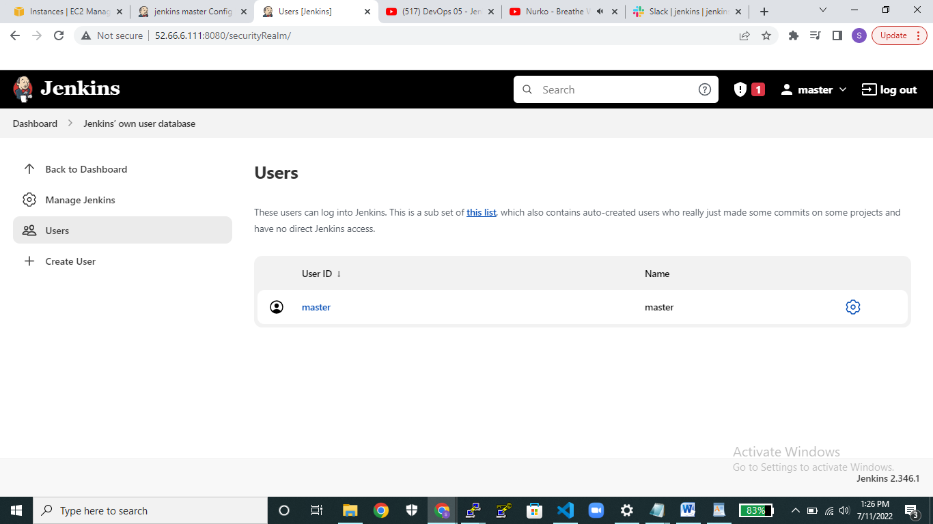  
  
**Step3**: click on create users provide username and password and all .  
  
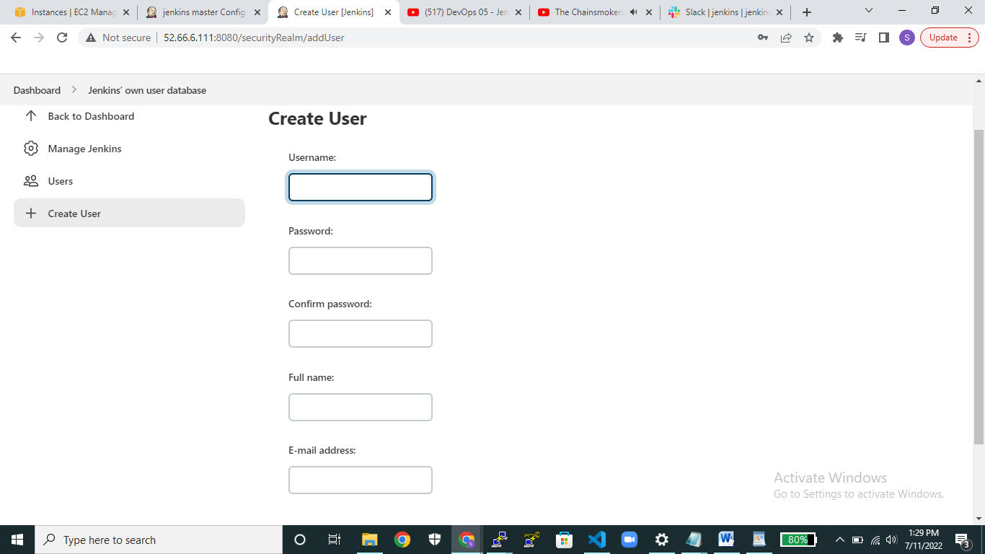

**Step 4**:Goto configure global security and uncheck allow users to signup   
  
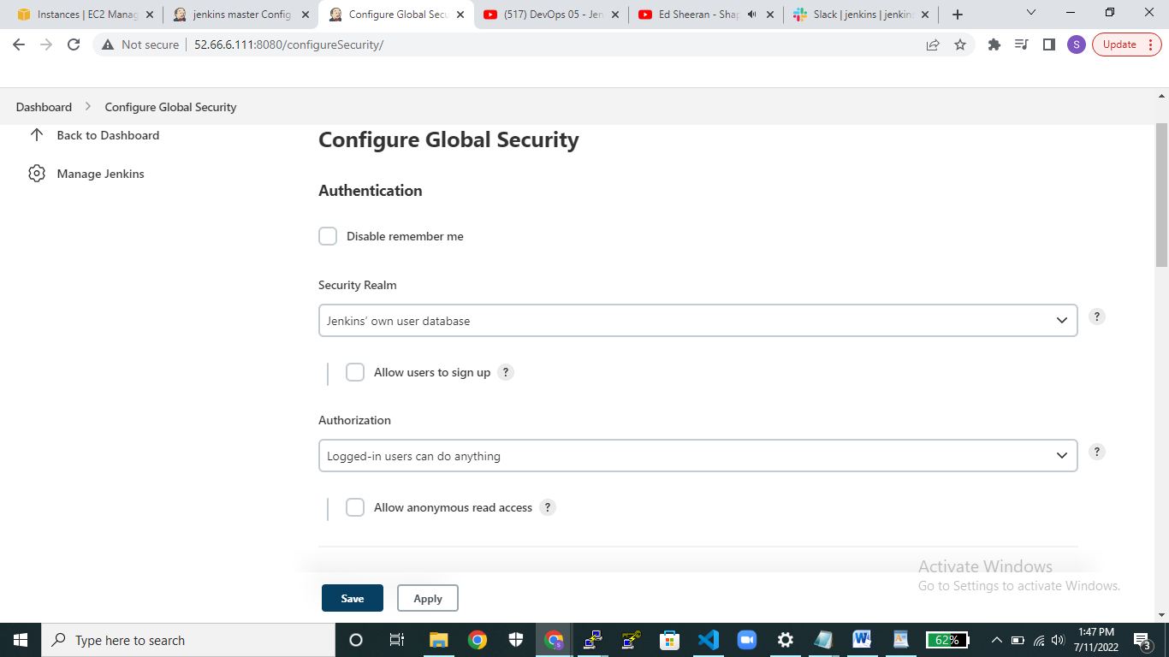  
  
In authorization select : **matrix-based security** and click on add user and give the created username  
where we create in manage users and after that pass whatever required do you want for specific user.  
And remain rest option same as like as and finally submit it .  
  
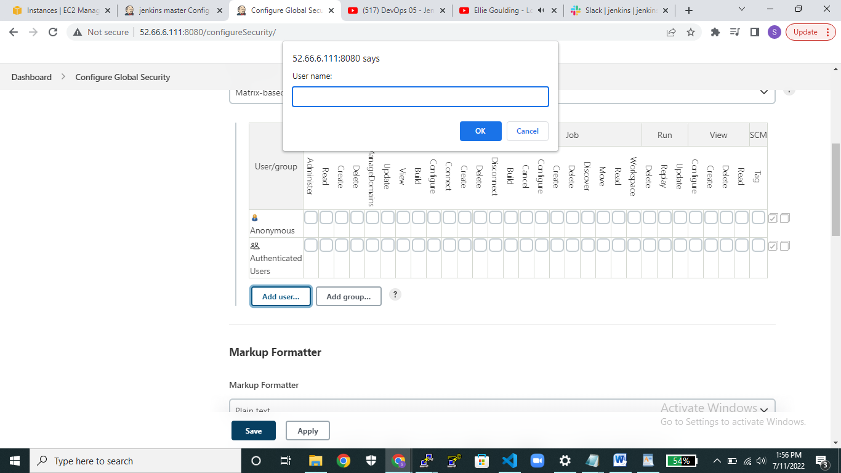

**step5**: second type of authorization :**project-based matrix authorization strategy**and click on add user and give the created username  
where we create in manage users and after that pass whatever required do you want for specific user.  
And remain rest option same as like as and finally submit it .  
  
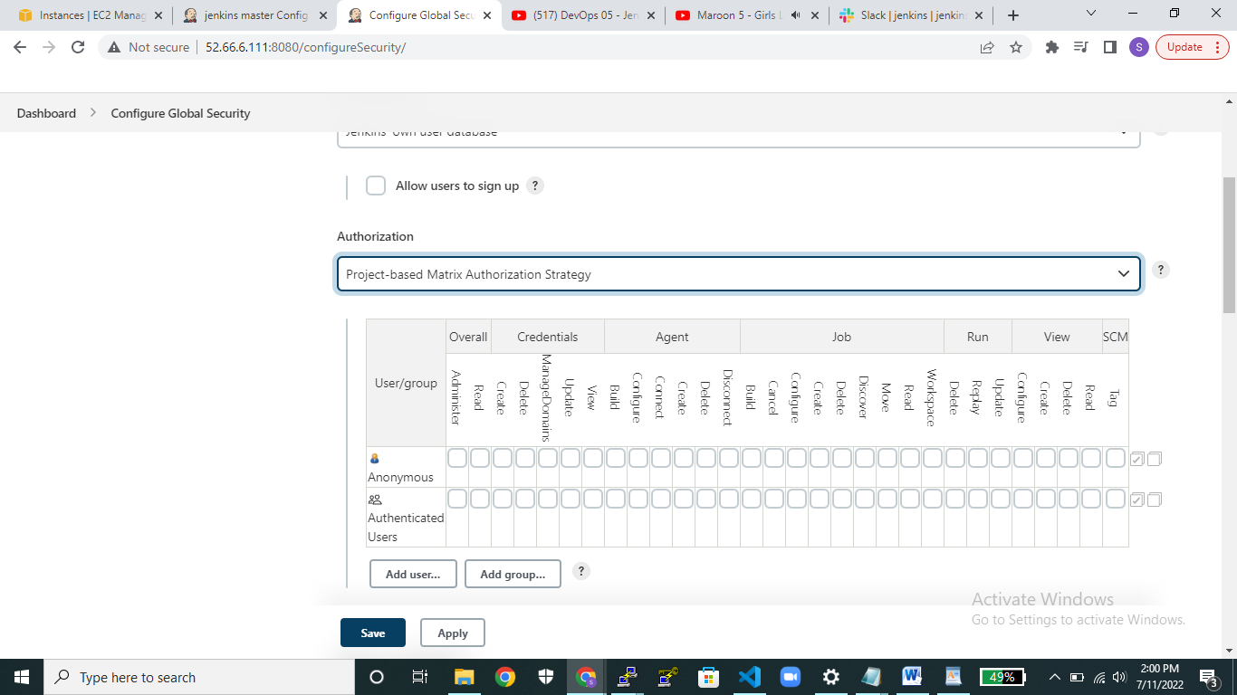

_________________________________________________________________________  
  
*** **Role-based authorization strategy** ***  
  
**Step1**: Goto manage plugins and download the Role based authorization strategy plugin.  
  
**step2**: click on managejenkins and go to manage users and create user .  
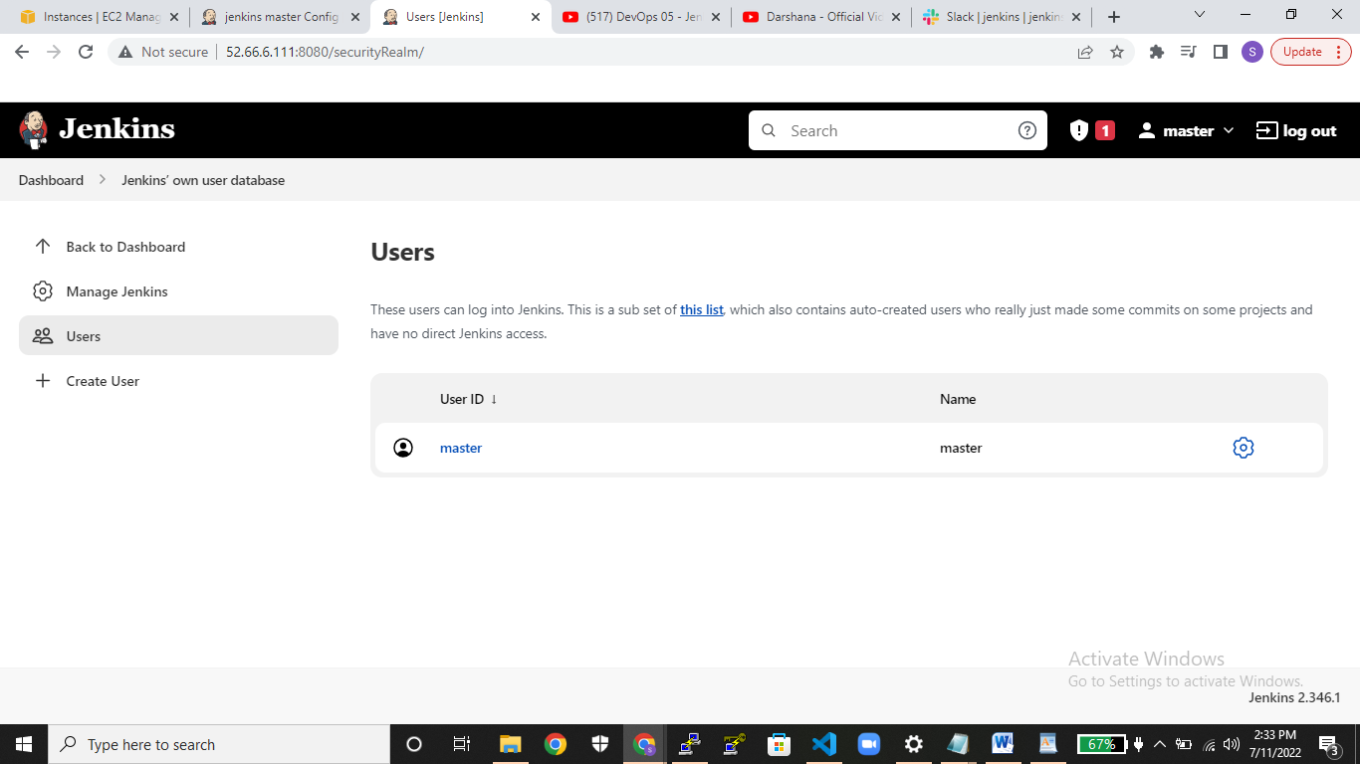  
  
 **step3:** after that provide username and password then submit create user .  
  
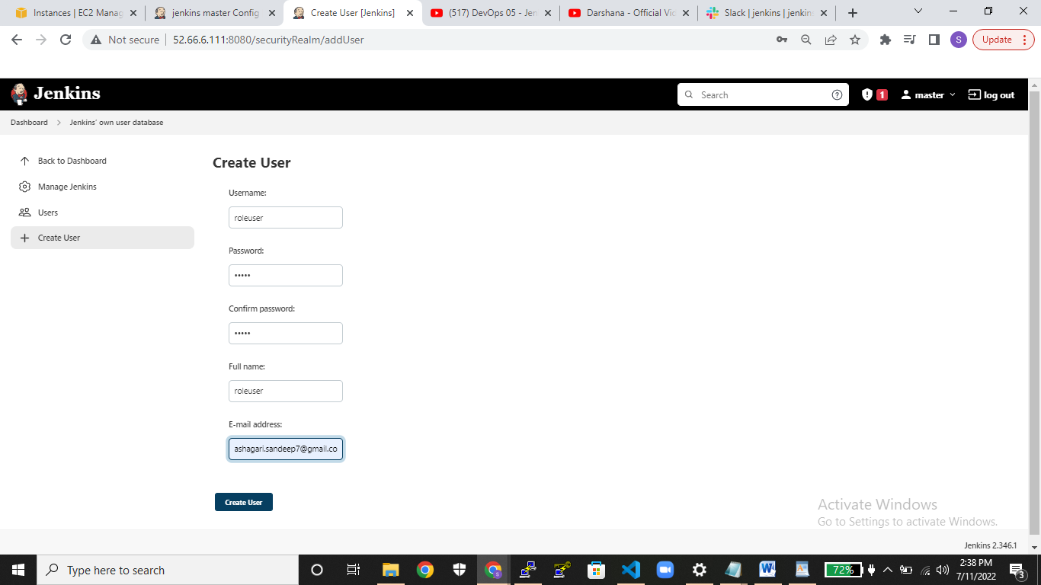  
 **step4: Goto** manage and assign roles page.  
  
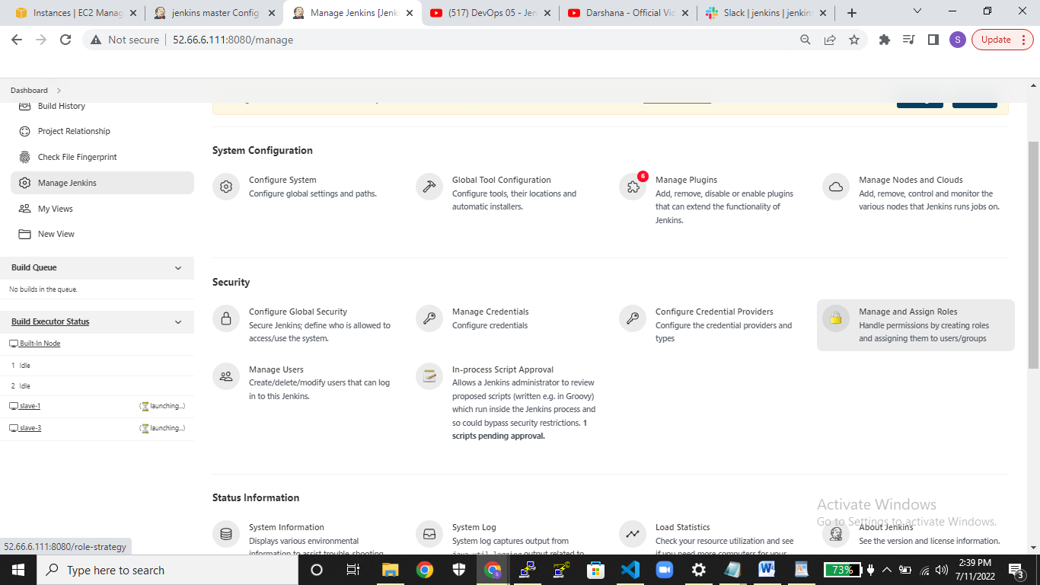  
  
 **step5:** go to manage roles option .  
  
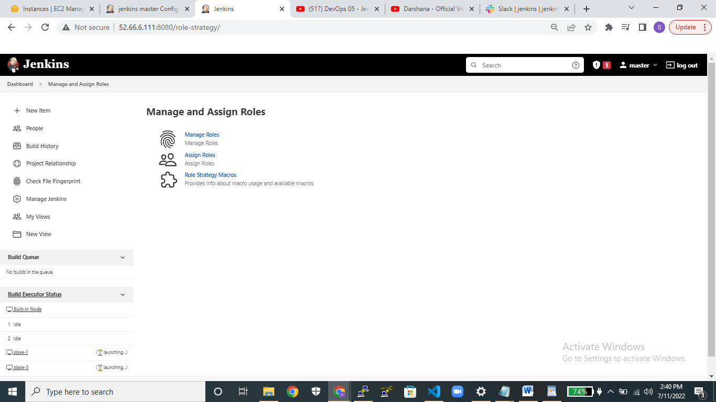 **step6: Go to**  manage roles create one role name under role to add and pass the required roles where you created in role to add (role name).  
  
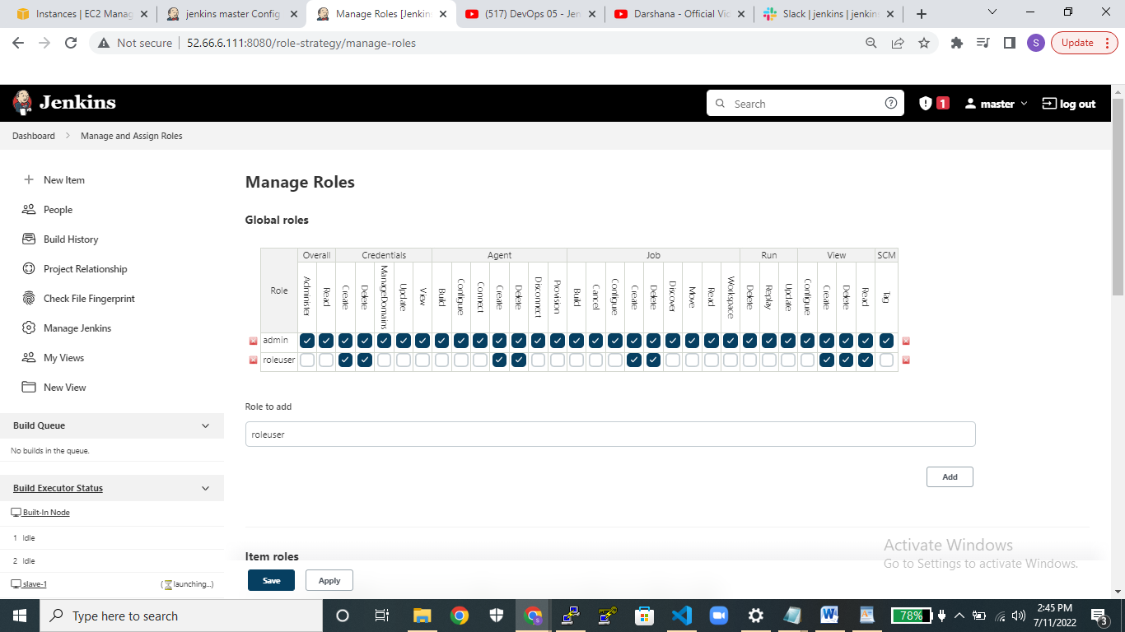  
  
 **step7:**  goto assign roles add user/group and provided name where you created user name in manage user portal provide that same name only under user/add group to add **&** and select that permission for created user in assign rules.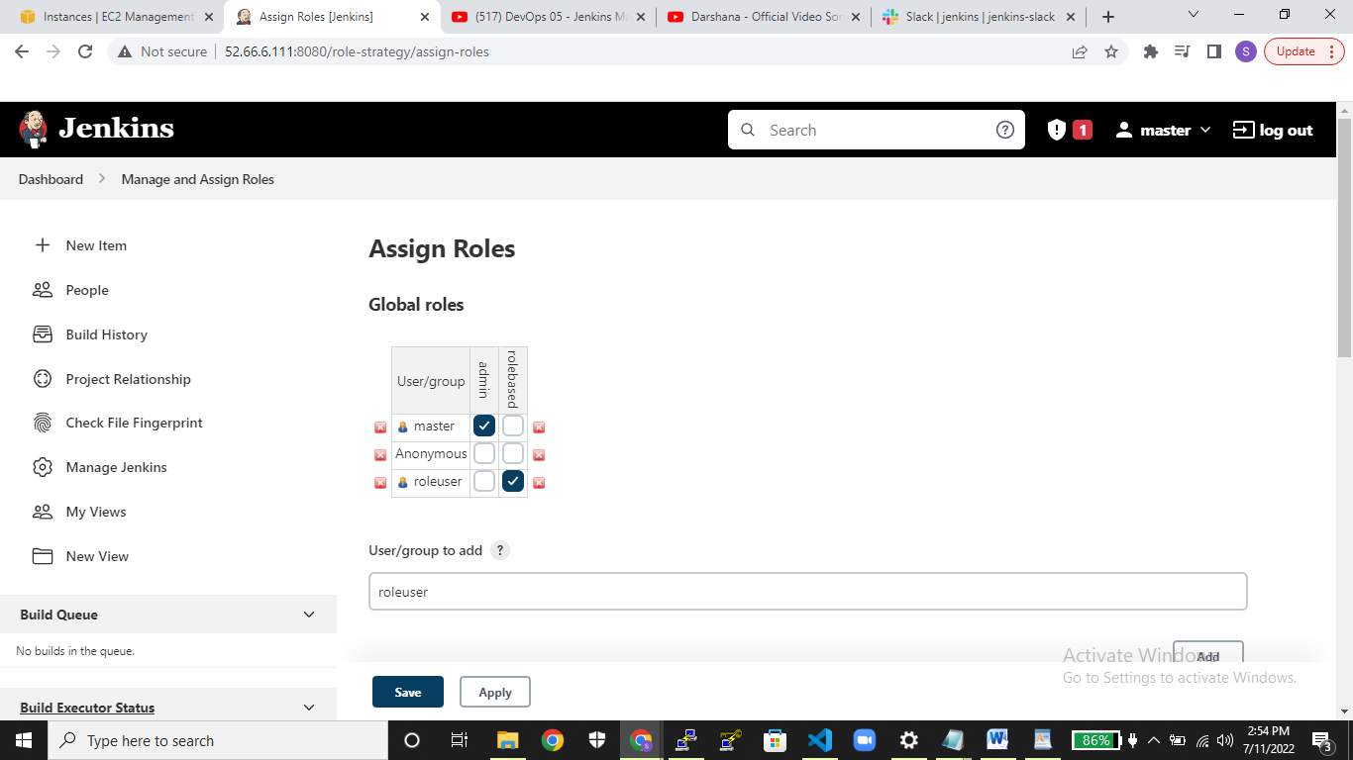  
 **conculsion:** this all above steps are used to secure the Jenkins dashboard and provide required dashboard access for specific users.